Crossroads International Church Singapore Dr. Rick Griffith
12 August 2018 Message 22 of 66
NLT 60 Minutes
Be Loving
Title
Song of Songs

Topic: Love
Subject: How can marital love become all that God designed?
Complement: Be loving by waiting and working.
Purpose: The listeners will become all that God designed for marriage by waiting for sex or working at their marriage.
Attribute: We worship the God of Love
Reading: Song 3:6-11
Songs: The Power of Your Love, Song of Love, The Love of God, He Will Hold Me Fast
Closing Song: “Restore” (Chris August) at https://www.youtube.com/watch?v=eb9_7b6-T6g

Introduction

Interest: Marriage is under attack.
Attack

The US Supreme Court redefined marriage in 2015.
Court
(5 slides)

Legalizing of polygamy is a natural future fear.
Polygamy

Now we are told there are 70 different sexes. This will not strengthen marriage!

Bill Cosby’s sexual failures and the #MeToo movement have highlighted how women have become abused.
Cosby

Bill Hybels also has confessed to multiple women, leading to his resignation and the resignations of Willow Creek’s senior pastor and entire elder board.
Hybels

Need: Assuming that you have God’s view of marriage right now, how will your biblical perspective on marriage last?
Isa 5:20

Even Christian leaders like Bill Hybels failed.

How can Isaiah 5:20 not apply to you and me?

Background: Marriage was under attack in Solomon’s day too.
Dialogue

Song of Songs is God’s marriage manual.

Marriage is the most intimate relationship in existence.

We should not be surprised to see a book in the Bible devoted to marriage.

In fact, we should be surprised if the Bible did not address this building block of every civilization!

The key word for this book is LOVE.
Love

The purity and simplicity of this book may indicate it was the first of Solomon’s three inspired writings.

Solomon later had 700 wives and 300 concubines.

It seems reasonable that he wrote this book before his viewpoint deteriorated.
Be Loving

I call this message “Be Loving” in the context of marriage.

People have always been curious about sex—but the Jewish solution was to keep people from the Song!
Fruit Boy

The book chart shows that this song is a dialogue of marital love.
Chart

Subject: How can marital love become all that God designed?
Subject

Preview: In this book we will see two ways to make marital love all that God wants—and he wants the best for you! This applies whether single or married, so don’t tune him out if you are single. Singles actually are making the most important decisions on marriage, which is where to start.
• 2 ways

Text: The two ways to make marital love all that God wants actually sum up the entire Solomon’s Song of Songs.

(So what is the first way to make marital love all that God wants?)

I. Wait for sex until marriage (1:1–5:1).
MP
[Be loving to God's person for you by preserving yourself now.]
Song 2
(4 slides)
1:2-3
[Solomon and the Shulammite begin their love relationship in courtship and marriage as an example of the need for premarital sexual restraint (1:1–5:1).]

Solomon and the Shulammite express deep sexual desire for one another during their courtship accompanied by sexual restraint (1:1–3:5).
Song 1
(2 slides)

Solomon considered this song the best of the 1005 songs that he composed (1:1).
1:1

Solomon and the Shulammite express longing, insecurity, and praise as a prelude to the content of the entire poem (1:2-11).

The Shulammite expresses her longing for Solomon that is reiterated by the friends (1:2-4b).
1:4a-b

The Shulammite expresses her longing for Solomon (1:2-4b).

The friends agree with her that Solomon deserves her praise (1:4c).
1:4c

Her insecurity as a tanned vine grower contrasts with the stately Solomon, whom she calls a shepherd as a term of endearment (1:5-7).
1:5-7
(3 slides)

Solomon responds to her insecurity with praise for her neck and cheeks (1:8-11).
1:8-11
(2 slides)

The courtship between lover and beloved intensifies but they remain patient until their wedding day (1:12–3:5).
1:12-14

Solomon and the Shulammite mutually praise the other as unique among those of their sex (1:12–2:6).
1:15-17
(3 slides)

The Shulammite advises young virgins of Jerusalem to avoid excessive sexual arousal before the proper marriage context (2:7).

As Solomon and the Shulammite visit her country homeland of Lebanon their mutual longing and intimacy grow (2:8-17).

The Shulammite dreams of losing her love but finds him and again warns the young virgins against premature sexual arousal (3:1-5).
Song 3
(2 slides)

The bride and groom experience a royal wedding and the intimacy of their wedding night (3:6–5:1).

Solomon arrives for their wedding with the great pomp of a royal wedding procession (3:6-11).
Wedding
(4 slides)

The groom praises his bride on their wedding night and they consummate their marriage (4:1–5:1). (Note: “bride” appears six times and only in this section.)
Song 4

Solomon praises his bride's body, love, and purity (4:1-15).
Cartoon

Solomon praises his bride's body and gives her security (4:1-7).

Solomon praises his bride's love and calls her away from her home country (4:8-11; cf. Ps. 45:10-11).

Solomon praises his bride's purity (4:12-15).

The Shulammite encourages her husband to consummate their marriage and he accepts her invitation (4:16–5:1).
4:16

The Shulammite invites Solomon to sexual union with her with the imagery of a garden (4:16).

Solomon declares that their union meets God's approval (some say this is the “friends” approval!) as the climax of the book (5:1).
Song 5
(3 slides)

(So can marital love become all that God designed? We have seen in the first movement of this story to wait for sex until marriage. So does that mean that once you get married all is well? No. The second part of the story exhorts us to…)
Sub/MP
(2 slides)

II. Work for a good marriage (5:2–8:14).
MP
[No relationship is built without sweat and tears.]
[The love of the couple matures through various events until it is very strong to show the effort needed to grow in marital love (5:2–8:14).]

The new marriage matures through struggles, praise, romance, and a request for greater intimacy to show that marital love takes work (5:2–8:4).
5:2-16
(7 slides)
Song 6
(2 slides)

The wife (not “bride” as in 4:1–5:1) dreams that she shuns her husband's advances and becomes reconciled again (5:2–6:13).

Sometime later the wife dreams that she shuns her husband's advances (5:2-8).

The Shulammite regrets rejecting her husband as she ponders his admirable qualities (5:9-16).

She pursues her husband for reconciliation (6:1-3).

Solomon responds to her request and praises her (6:4-13).

Solomon praises the Shulammite’s beauty and she responds with a request for a romantic stroll and greater intimacy (7:1–8:4).
Song 7
(3 slides)

Solomon praises the Shulammite for her beauty and ability to fulfill him sexually (7:1-9a).

She responds to his request but also requests a countryside stroll and deeper intimacy in their marriage (7:9b–8:4).
Desire

The Shulammite praises love's strength and their love story is reviewed in flashback form (8:5-14).
Song 8

The beloved exults in the awesome strength of genuine love by declaring that it is as universal and irresistible as death (8:5-7).
8:6-7

The love story of Solomon and the Shulammite is reviewed in flashback form (8:8-14).

The brothers of the Shulammite protected her from losing her virginity while she was young (8:8-9).
8:8-9

The Shulammite acknowledges that she saved herself for Solomon (8:10-12).
8:11-12

Solomon and the Shulammite affirm that their love has not lost its intensity (8:13-14).
Sum/Sub
(2 slides)
MPII
(So can marital love become all that God designed?)

Conclusion

Main Points

Wait for sex until marriage (1:1–5:1).
MPI

Work for a good marriage (5:2–8:14).

Be loving by waiting and working (Main Idea).
MI

What should I do?
Trouble

Singles: Exercise premarital sexual restraint so that marriage can be enjoyed to its fullest (i.e., allow love to blossom in its own time–2:7b; 3:5b; 8:4b).
Singles
(3 slides)

Marrieds:
Adultery
(2 slides)

Expect a good marriage to take work, and then work at it.

Compliment both the physical and non-physical virtues of your spouse.
Compliment

Prayer
Black

“Restore” (Chris August) at https://www.youtube.com/watch?v=eb9_7b6-T6g
Restore

Silent Meditation

Preliminary Questions

Verses Questions

Context: What did the author record just prior to this passage?

The purity and simplicity of this book may indicate it was the first of Solomon’s three inspired writings.

Likely Proverbs followed this book.

Purpose: Why is this passage in the Bible?

Marriage is the most intimate relationship in existence.

We should not be surprised to see a book in the Bible devoted to marriage.

In fact, we should be surprised if the Bible did not address this building block of every civilization!

Background: What historical context helps us understand this passage?

Solomon later had 700 wives and 300 concubines.

It seems reasonable that he wrote this book before his viewpoint deteriorated.

Questions

Does the book really show a progression from courtship to marriage?

Was Solomon hiding his identity in the narrative?

Tentative Main Ideas

Text

Illustrations That Apply

Text

Old Testament Survey Notes

Solomon's Song of Songs

Introduction

I. Title: The name Song of Songs (~yriyVihæ ryvi) is the most exalted way to designate a musical work as the best possible (BDB 1010b), or "the finest song" (LaSor, 601). This song was therefore the best of the 1005 songs composed by Solomon (1 Kings 4:32), whose name (hmolov])) is related to the Hebrew adjective (~lev;) which means "complete, safe, at peace" (BDB 1023d). Here then is what he whose name means “peace” deemed the best of all his songs.

II. Authorship

A. External Evidence: The earliest Jewish tradition attributes the work to Solomon. This finds support in that Solomon wrote 1005 songs (1 Kings 4:32), so it would not be unusual to find the best of them within the Scriptures. Those who doubt about its suitability for the Hebrew canon should note the strong affirmation of its usefulness by Rabbi Akiba (ca. AD 100): "The whole world is not worth the day on which the Song of Songs was given to Israel; all the Writings are holy, and the Song of Songs is the holy of holies" (Mishnah, Tractate Yadaim 3.5). Any early opposition most likely came due to its erotic nature.

B. Internal Evidence: The genitive designation "which is Solomon's" (hmolov]li rv,a}; 1:1) has been challenged by critical scholars who claim that it more properly means "which is about or concerning Solomon," "for Solomon," or "in the style of Solomon" (e.g., LaSor, 601; Harrison, 1049). Solomonic authorship is also denied based upon the presence of Aramaic influence, the relative pronoun characteristic of later Hebrew, and supposed later Persian and Greek loanwords (e.g., "orchard," 4:13; "chariot," 3:9; cf. LaSor, 602, n. 4).

However, this interpretation of 1:1 is unwarranted as the normal use of the genitive li rv,a} (1:1) is to state the possessor (GKC, 420 §129h) which is well substantiated (Gen. 29:9; 40:5; 47:4; Ruth 4:3; 1 Sam. 21:8; 2 Sam. 2:8; 1 Chron. 11:10; etc.). The other linguistic arguments above are also speculative. Repeated refrains also argue for the unity of the book (e.g., “Do not arouse or awaken love until it so desires,” 2:7b; 3:5; 8:4).

C. Summary: Several evidences support Solomon as the author:

1. Solomon is expressly identified as author in the title (1:1).

2. Jewish tradition attributes the work to none other.

3. Solomon wrote 1005 songs and his proverbs (e.g., Book of Proverbs) demonstrate the literary skill required of such a masterful love song (1 Kings 4:32-33).

4. Solomon is noted by name six other times in the poem (1:5; 3:7, 9, 11; 8:11, 12) and is called "the king" (1:4, 12; 7:5).

5. Solomon's keen interest in nature (1 Kings 4:33) is evident in the many references to plants (1:17), animals (1:8, 9), minerals (8:11), and jewels (4:9).

6. Eighteen places throughout the empire are mentioned in the book, alluding strongly to a time before the monarchy divided.

7. Many costly items that Solomon imported are mentioned (1:12-13; 3:6, 9).

III. Circumstances

A. Date: Solomon's reign lasted 40 years (971-931 BC) and he probably wrote this song early in life, whether the 60 queens and 80 concubines (6:8) are his own or are just a hypothetical figure. Critics who deny Solomon as author date the work much later even into the fourth century BC.

B. Recipients: One scholar identifies the lavishness in the book (e.g., 3:6-11) with "the pomp and circumstances of the Persian Empire and the luxurious palaces of the Great King at Susa (Shushan) and Persepolis" (H. J. Schonfield, The Song of Songs [New York, 1959], 75-83; cited by LaSor, 603). However, a setting in Israel pervades the work and, given its early date, it is undoubtedly for Hebrews (though rabbis would not let men read it until age thirty!).

C. Occasion: One minority view sees three characters in view where Solomon tries to use his kingly splendor to woo the Shulammite away from her true shepherd-lover (cf. Ewald; Driver; Ginsberg; Archer, Encyclopedia of Bible Difficulties, 262; John Phillips, Exploring the Scriptures [Chicago: Moody, 1965], 116). Although he wants her to become one of his wives, she successfully resists him and is reunited with her true love at the end. However, this view sees 4:1-6 as spoken by Solomon while 4:7-15 as said by the shepherd—an unlikely distinction. Besides, Solomon had flocks (Eccles. 2:7).

A two-speaker view seems better. The key to the story line may be in 8:11-12 where it mentions Solomon’s vineyard in Baal Hamon (location unknown). If this city is near the city of Shunem (cf. Abishag the Shunammite, 1 Kings 1:3, 15) and this is the same place from which the Shulammite (6:13) comes then it may be the same garden in which she worked. (Possibly Shulammite is the same as Shunammite.) H. A. Ironside interprets the story as one of a poor family in Ephraim in which exists a girl who is a sort of a Cinderella. She is forced to work in the vineyards where she meets a young shepherd (1:5-7). The two fall in love but he leaves her with the promise that he will return. One day the electrifying word is shouted that King Solomon was coming by (3:7). The young woman is not interested until word reaches her that the king wants to see her. She is puzzled until being brought into his presence where she recognizes her young lover to be Solomon himself! He takes her into his palace in Jerusalem where most of the song takes place with some scenes as flashbacks.

Two questions naturally arise in relation to this setting for the Song: (1) Why did Solomon write such a description of love, and (2) How could he, a polygamist, be qualified to express the wonders of a monogamous relationship—especially if the sixty queens and eighty concubines mentioned (6:8) are his own? Several answers can be given:

1. Some suppose that the account is not actually historical, so his purpose in writing is to show God's ideal even though he neglected to follow his own advice. However, this view is unacceptable as the account describes an actual relationship Solomon had with a Shulammite maiden and it specifies many actual places that they went together.

2. While later in his life he had 700 wives and 300 concubines (1 Kings 11:3), this Song certainly does not exalt polygamy. Perhaps it was the peril of polygamy itself that motivated this beautiful description of monogamy as God intended (Gen. 2:24).

3. Solomon married primarily, if not exclusively, for political reasons that may not have included sexual relations (Rehoboam is his only son mentioned in Scripture).

4. Solomon may not have yet been a polygamist at the time of composition—especially if the 140 women of 6:8 were not his own but only an exalted number of woman which, compared to the Shulammite, failed in comparison (6:9). This explanation may have the most weight since he didn’t become a polygamist until he was old (1 Kings 11:4) while he probably wrote this account early in life (see Date above). Therefore, the Shulammite was his first wife before he fell into sin.

IV. Characteristics

A. Solomon's Song of Songs remains only one of two books in Scripture that never mentions God (the other being Esther). However, while Esther mentions fasting, the Canticle is completely void of any religious material.

B. The Song is mentioned nowhere else in the Bible (neither quotes nor allusions).

C. “The Song of Solomon is the first of the five Megilloth, the five scrolls read by the Jews at various feasts: Canticles (Passover), Ruth (Pentecost), Ecclesiastes (Tabernacles), Esther (Purim), and Lamentations (anniversary of the destruction of Jerusalem)” (R. K. Harrison, Introduction to the Old Testament, 1049).

D. This is the only book which ancient Jews prohibited men from reading until age 30!

E. In eight or more verses it is difficult to know who is speaking. “One of the most difficult tasks is to determine who the speaker is in each verse. It is not even completely clear how many speakers there are. Our best clues are grammatical. Fortunately, pronominal references in Hebrew commonly reflect gender and number. In some cases, however, the masculine and feminine forms are the same” (Dennis F. Kinlaw, EBC, 5:1211). Here is one attempt to determine the correct speakers:

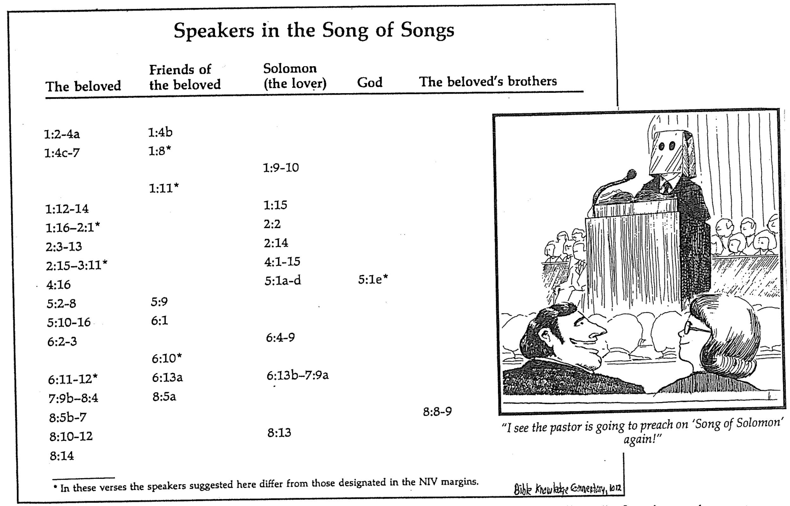

F. This book has the most interpretive views in the entire Bible. In fact, it was the most studied biblical book of the Middle Ages! The following summarizes in general the main hermeneutical approaches, which also touch on the issues of literary genre and unity:

1. Allegorical Views see no historical situation (human love) and relate the book only to divine love. Yet all allegories are speculative, not textually based, and have led to many excesses. Origen said the darkness (1:5) is the church’s sin, Hippolytus interpreted the breasts (7:3) as the two testaments, and others noted that the cooing of doves (2:12) is the apostles’ preaching and the “eating and drinking” (5:1) is the Lord’s Supper!

a. Jewish allegories see the book as relating God's love for Israel (cf. Mishnah, Talmud, Targum, Rabbi Akiba).

b. Pagan allegorical views see the Song as a sacred marriage rite celebrating the reunion and marriage of the sun god with the mother goddess of Mesopotamia (cf. Kramer, Theophile Meek) or the cultic wedding of the goddess Ishtar and the god Tammuz (Meek, Margolis, Snaith, etc.). However, these pagan associations render the view untenable given that the original readers were Jews.

c. Christian allegories view the relationship as between Christ and the Church (Protestant; cf. Origen, Hippolytus, Augustine), the individual (cf. Bernard of Clairvaux), the “mystical union of the soul with God” (Origen and Gregory of Nyssa), or the Virgin Mary (Catholic; cf. Ambrose, Buzy, Bea, etc.). Martin Luther saw in the bride a happy and peaceful Israel under Solomon’s rule (EBC, 5:1203). Between AD 1135 and 1153 Bernard of Clairvaux preached 86 sermons on the Song of Songs yet never went beyond 3:1 before his death! Such is allegory! The allegorical view became so popular in the Middle Ages that more commentaries were written on the Song than on any other book.

2. Typological Views see a historical situation (human love) as a type of divine love. These include viewing the Song as typifying the relationship between God and Israel or the Church (cf. Archer, Kinlaw [EBC, 5:1208]), between Christ and the Church (cf. Delitzsch), or between Christ and the individual (cf. Copley, Nee, J. Hudson Taylor, Irving L. Jensen). However, these also are speculative as they lack support in the book itself and from the NT.

3. Literal Views see a historical situation of human love without an underlying meaning.

a. The rustic wedding song theory sees the account as depicting a country wedding (cf. R. H. Pfeiffer), but the lavishness of 3:6-11 makes this impossible, especially since these are the only verses that refer to a wedding.

b. The anthological theory finds in the Song only disconnected poems about love (cf. Davidson, Jastrow, Rowley, Soulen, Pfeiffer, Gordis, Cassuto), but this ignores the prominence of Solomon and the unity supported by repeated refrains (2:7; 3:5; 8:4), repeated characters, and progression of thought (see "Argument" below). Those holding to this collection of love poems use the plural term “Canticles” (songs) for the book.

c. The funeral love feast theory asserts (based on 8:6) that the book celebrates a sacral meal that accompanied the death of a loved one in early Mesopotamia and Ugarit (cf. Pope). This view fails to see that a marriage, not a funeral, is in view. Also, its mythological fertility cult origin is incompatible with Old Testament theology.

d. The dramatic theory has the Song written for stage performances (cf. Delitzsch, Amplified Bible, Seerveld, Driver, Jacobi), but this also must be rejected, as dramatic forms did not exist when it was written and the necessary scripting is lacking.

e. The normal marital love theory notes the marriage elements but without sexual overtones. It was first proposed by Moses Mendelssohn (1729-1786) and later this century followed by Ginsburg, Young, and Zuck.

f. The marriage sex theory believes the poem provides sexual instructions for couples (cf. Joseph Dillow). While the Hebrew language had no word for “bachelor” (there weren’t any!) and virginity and barrenness were seen as curses (Judg. 11:34-40), still the sexual act appears only twice in the Song of Songs (4:16–5:1; 7:7-10) which makes this view close but not completely on target.

g. The natural sense of the Song depicts a dialogue of marital love designed to encourage the praise of one's spouse as unique and special (cf. Theodore of Mopsuetia; Grotius; Clericus; S. Craig Glickman, Song for Lovers (IVP); Charles and David Webber; R. K. Harrison, Zondervan Pictorial Encyclopedia of the Bible, 5:493; Roland E. Murphy, “Interpreting the Song of Songs,” Biblical Theology Bulletin 9 (July 1979): 99-105). This is supported by the fact that the entire book is a conversation and the flow traces the development of marital love (see "Argument" and "Outline" below).

For a more thorough survey of interpretive viewpoints to the Song and support for the last option, see J. Paul Tanner, “The History of Interpretation of the Song of Songs,” Bibliotheca Sacra 154 (January-March 1997): 23-46; J. Paul Tanner, “The Message of the Song of Songs,” Bibliotheca Sacra 154 (April-June 1997): 142-61.

G. Why are there so many interpretations of this book?

1. Lack of Structure

2. Difficulty in determining the number of characters and who is speaking

3. Embarrassment of the interpreter who attempts to take this as referring to sexual love

4. Symbolic language is not always easy to interpret

Argument

Solomon's Song of Songs expresses the deepest of emotions between Solomon and his Shulammite wife, tracing their relationship from courtship to the depths of love as a married couple growing in devotion towards one another. The song has two major parts. The first major movement (1:1–5:1) traces the couple's yearning for one another in courtship (1:1–3:5) that is culminated in their wedding and wedding night (3:6–5:1) as an example of premarital sexual restraint. This purpose of sexual restraint is seen in the repeated refrain, “Do not arouse or awaken love until it so desires” (2:7b; 3:5; 8:4). The second major movement (5:2–8:14) relates the difficulties of obtaining a strong marital love that shows the effort necessary for love to grow to its potential. The form in which the entire Song of Songs is presented is dialogue or communication, which is the key to developing all deep and abiding relationships—especially in marriage.

Synthesis

Dialogue of marital love

1:1–5:1 Courtship to wedding
1:1–3:5 Courtship sexual desire
1:1 Title
1:2-11 Longing, insecurity, praise
1:12–3:5 Intensification in purity
3:6–5:1 Wedding sexual fulfillment
3:6-11 Procession
4:1–5:1 Consummation

5:2–8:14 Growth in marriage
5:2–8:4 Growth
5:2–6:13 Struggles
7:1–8:4 Praise and response
8:5-14 Flashback of love's strength

Outline

Summary Statement for the Book
The love story of Solomon and his Shulammite wife from courtship to strong marital love shows the need for premarital sexual restraint and the effort required for growth in marital love.

Solomon and the Shulammite begin their love relationship in courtship and marriage as an example of the need for premarital sexual restraint (1:1–5:1).

Solomon and the Shulammite express deep sexual desire for one another during their courtship accompanied by sexual restraint (1:1–3:5).

Solomon considered this song the best of the 1005 songs that he composed (1:1).

Solomon and the Shulammite express longing, insecurity, and praise as a prelude to the content of the entire poem (1:2-11).

The Shulammite expresses her longing for Solomon that is reiterated by the friends (1:2-4b).

The Shulammite expresses her longing for Solomon (1:2-4b).

The friends agree with her that Solomon deserves her praise (1:4c).

Her insecurity as a tanned vine grower contrasts with the stately Solomon, whom she calls a shepherd as a term of endearment (1:4c-7).

Solomon responds to her insecurity with praise for her neck and cheeks (1:8-11).

The courtship between lover and beloved intensifies but they remain patient until their wedding day (1:12–3:5).

Solomon and the Shulammite mutually praise the other as unique among those of their sex (1:12–2:6).

The Shulammite advises young virgins of Jerusalem to avoid excessive sexual arousal before the proper marriage context (2:7).

As Solomon and the Shulammite visit her country homeland of Lebanon their mutual longing and intimacy grow (2:8-17).

The Shulammite dreams of losing her love but finds him and again warns the young virgins against premature sexual arousal (3:1-5).

The bride and groom experience a royal wedding and the intimacy of their wedding night (3:6–5:1).

Solomon arrives for their wedding with the great pomp of a royal wedding procession (3:6-11).

The groom praises his bride on their wedding night and they consummate their marriage (4:1–5:1). (Note: “bride” appears six times and only in this section.)

Solomon praises his bride's body, love, and purity (4:1-15).

Solomon praises his bride's body and gives her security (4:1-7).

Solomon praises his bride's love and calls her away from her home country (4:8-11; cf. Ps. 45:10-11).

Solomon praises his bride's purity (4:12-15).

The Shulammite encourages her husband to consummate their marriage and he accepts her invitation (4:16–5:1).

The Shulammite invites Solomon to sexual union with her with the imagery of a garden (4:16).

Solomon declares that their union meets God's approval (some say this is the “friends” approval!) as the climax of the book (5:1).

The love of the couple matures through various events until it is very strong to show the effort needed to grow in marital love (5:2–8:14).

The new marriage matures through struggles, praise, romance, and a request for greater intimacy to show that marital love takes work (5:2–8:4).

The wife (not “bride” as in 4:1–5:1) dreams that she shuns her husband's advances and becomes reconciled again (5:2–6:13).

Sometime later the wife dreams that she shuns her husband's advances (5:2-8).

The Shulammite regrets rejecting her husband as she ponders his admirable qualities (5:9-16).

She pursues her husband for reconciliation (6:1-3).

Solomon responds to her request and praises her (6:4-13).

Solomon praises the Shulammite’s beauty and she responds with a request for a romantic stroll and greater intimacy (7:1–8:4).

Solomon praises the Shulammite for her beauty and ability to fulfill him sexually (7:1-9a).

She responds to his request but also requests a countryside stroll and deeper intimacy in their marriage (7:9b–8:4).

The Shulammite praises love's strength and their love story is reviewed in flashback form (8:5-14).

The beloved exults in the awesome strength of genuine love by declaring that it is as universal and irresistible as death (8:5-7).

The love story of Solomon and the Shulammite is reviewed in flashback form (8:8-14).

The brothers of the Shulammite protected her from losing her virginity while she was young (8:8-9).

The Shulammite acknowledges that she saved herself for Solomon (8:10-12).

Solomon and the Shulammite affirm that their love has not lost its intensity (8:13-14).

Places in Solomon’s Song

Irving L. Jensen, Ecclesiastes & Song of Songs: A Self-Study Guide, 59

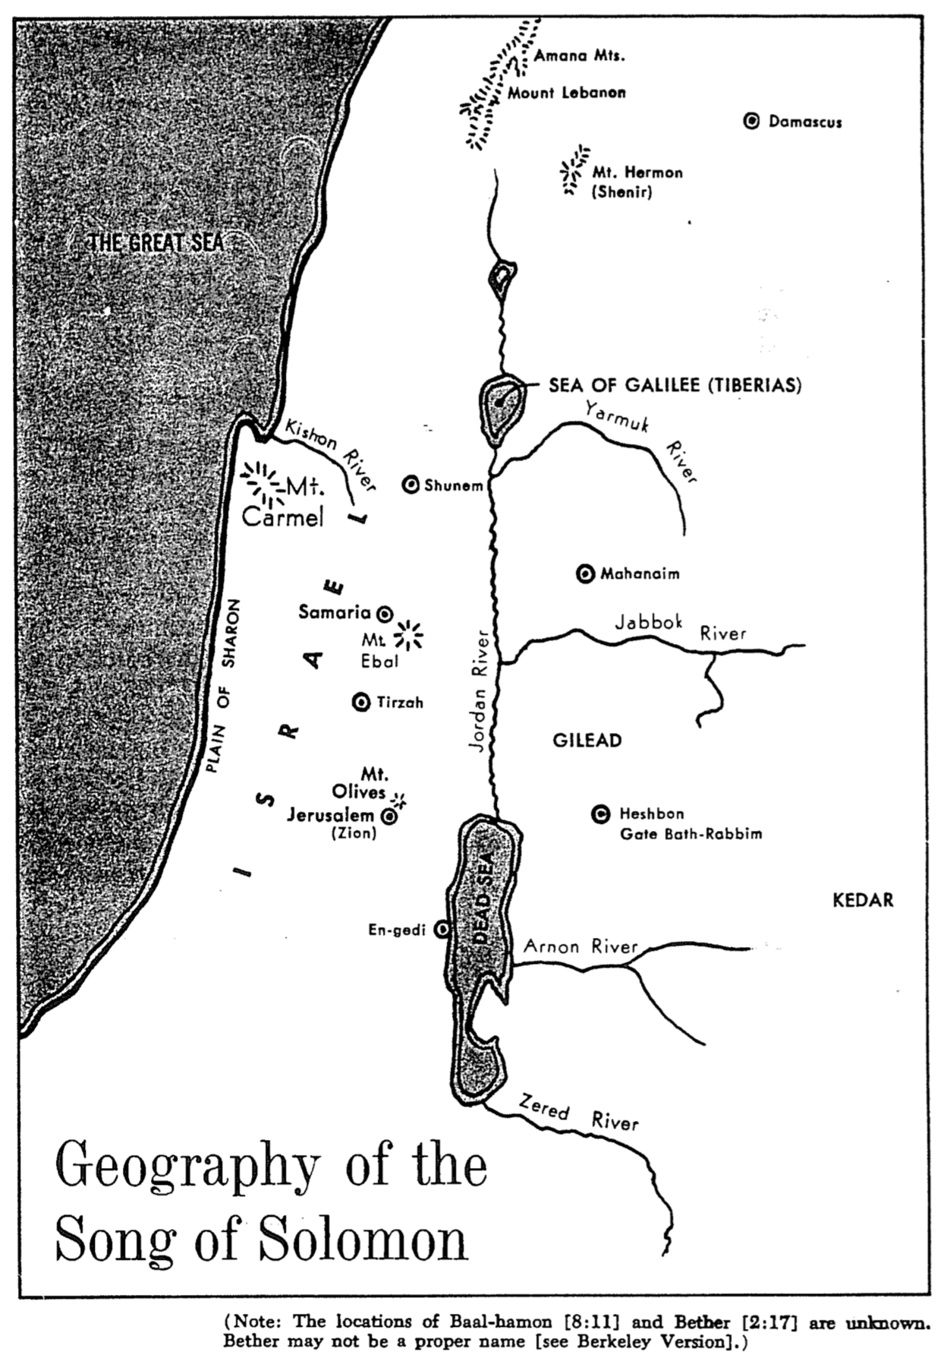

Aspects of Love

Irving L. Jensen, Ecclesiastes & Song of Songs: A Self-Study Guide, 69-70

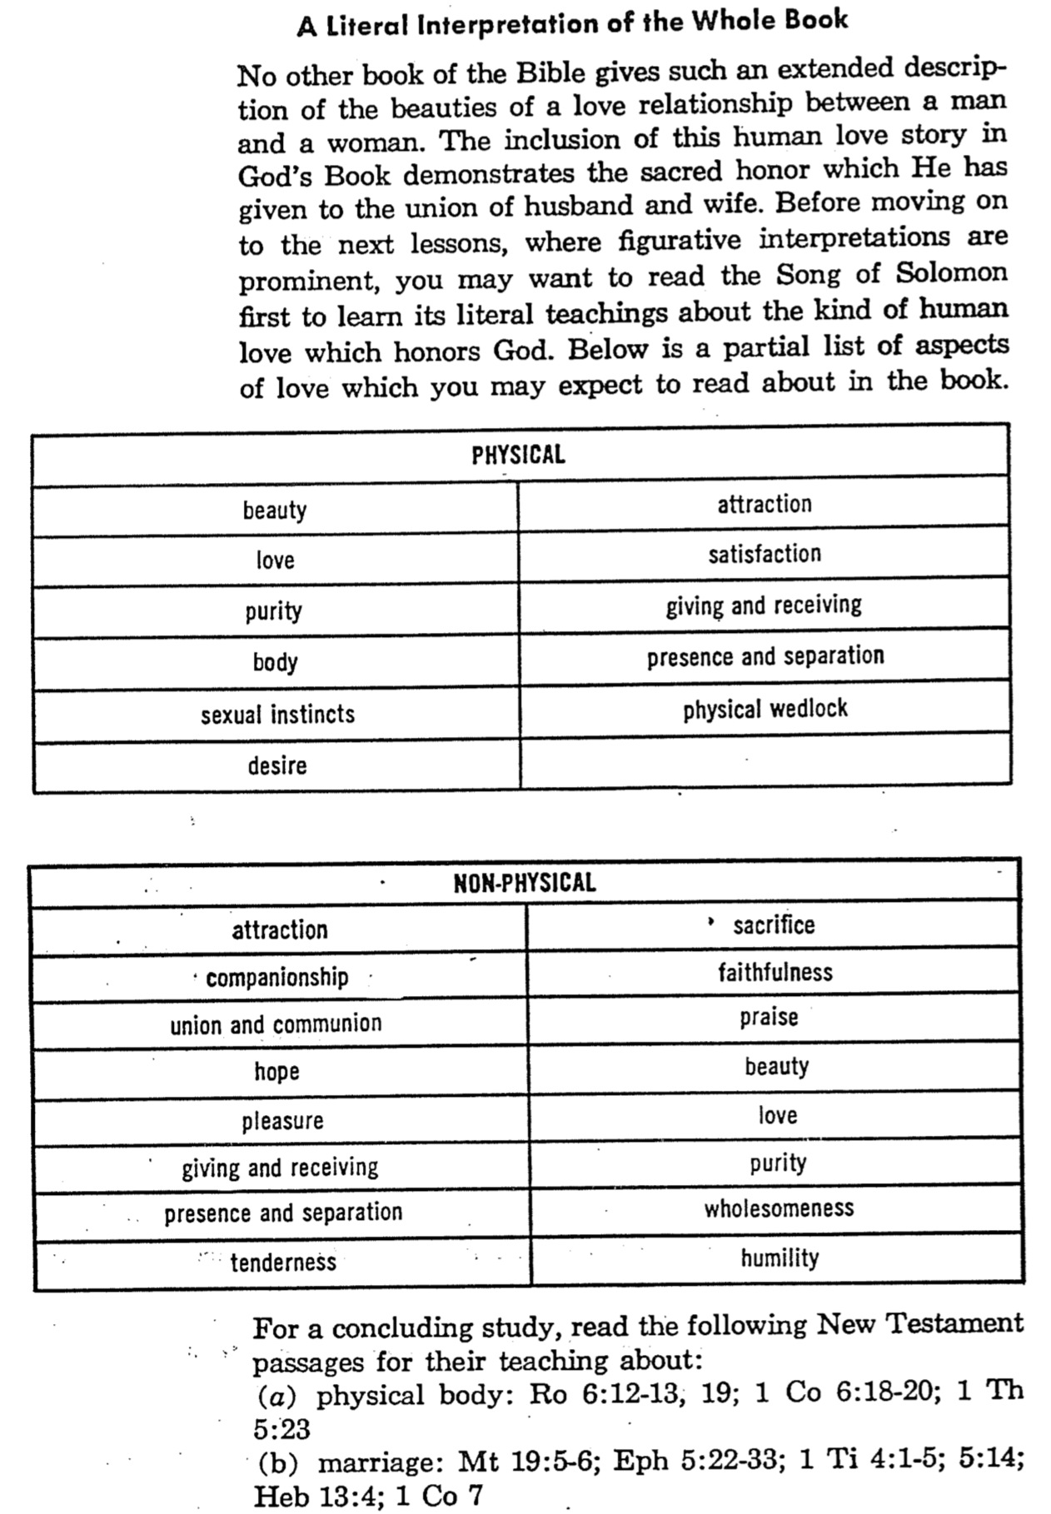

Male vs. Female Communication

One could get the idea from Song of Songs that men and women both communicate the same way. After all, both the Beloved (woman) and the Lover (man) express themselves beautifully.

Such is not the case, however. The following summarizes but a few differences between the two sexes that influence their modes of communication.

 | Male | Female
Emotions | “Do-ers” | “Be-ers”
Leadership | Achiever | Helper
Spiritual Values | Less important | More important
Verbal Content | Work | Home
Concern | Bottom line | Details
Source | Head | Heart
Pursuit | Risk | Security
Handling Data | File cabinet | Sleigh bells
Objectivity | Objective | Subjective
Primary Communication | Words | Non-verbal factors
Number of Words | 25,000 Daily | 30,000 Daily
Time Orientation | Present | Timeless
Number of Friends | Fewer | Greater
Energy Spent on… | Tasks | Relationships
Distraction | Easily Distracted | Less Easily Distracted
Temperament | Reticent | Expressive
Communication Focus | Directed | Multifaceted
Communication Style | Direct/frank | Indirect/tactful

For Further Study on Male-Female Differences Consult These Classics:

Crabb, Larry. Men & Women: Enjoying the Difference. Grand Rapids: Zondervan, 1991, 1993.

Osborne, Cecil. The Art of Understanding Your Mate. Grand Rapids: Zondervan, 1970.

Trobisch, Walter. I Loved a Girl. Kehl/Hein, Germany: Editions Trobisch, 1965.

Wright, H. Norman. Communication: Key to Your Marriage. Ventura, CA: Regal, 1974.
The Song of Solomon Illustrated
(for our literalist friends)
The Door 41 (February-March 1978)

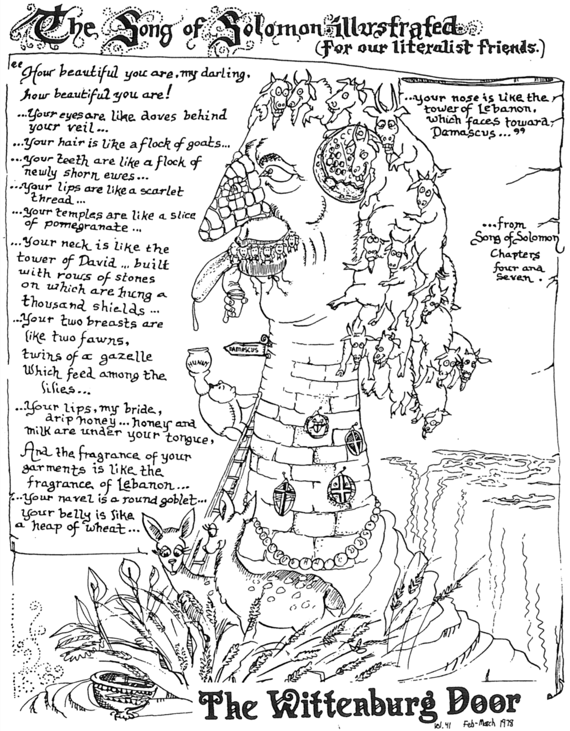

Increases in Premarital Sex
Compiled by Dr. Danny Goh, Singapore Bible College, January 2002

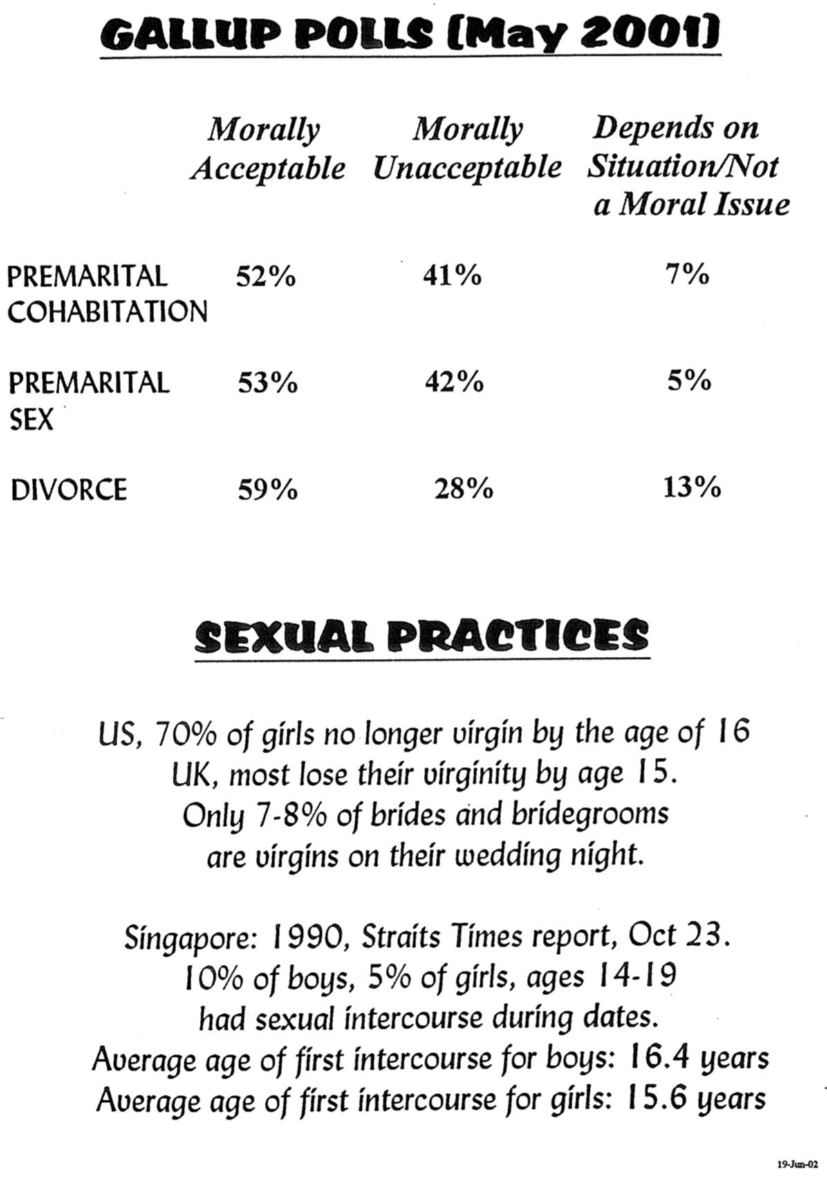

Exhortations for Premarital Sex
Compiled by Dr. Danny Goh, Singapore Bible College, January 2002

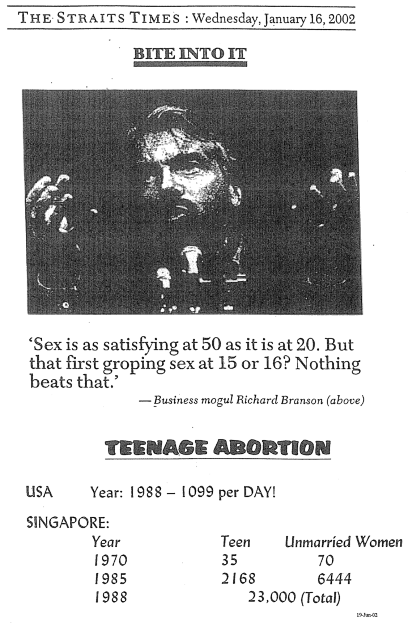

Reasons to Avoid Premarital Sex

A potential marriage partner must model trust now that s/he will be a faithful spouse after marriage.

- If a man will go to bed now with someone who is not his spouse, what makes him think that marriage will magically clean up his sexual morals? The same applies to women.
- Even engaged couples that have sex with the promise of future marriage still show that they have no conviction against sex outside of marriage.
- One who engages in premarital sex cannot logically argue against extramarital sex. To do so is hypocrisy.

Those who begin marriage as a virgin have the best chance of a successful marriage.

Most relationships break up after premarital sex.

Sexually transmitted diseases (the worst being AIDS) can result from sex with loose people.

God says to reserve sex for marriage.

- This is the best reason for premarital abstinence.
- As the author of marriage and sex, He knows what is best for us.

Be Loving
Song of Songs

Exegetical Outline (Steps 2-3)

Exegetical Idea: The love story of Solomon and his Shulammite wife from courtship to strong marital love shows the need for premarital sexual restraint and the effort required for growth in marital love.

Solomon and the Shulammite begin their love relationship in courtship and marriage as an example of the need for premarital sexual restraint (1:1–5:1).

Solomon and the Shulammite express deep sexual desire for one another during their courtship accompanied by sexual restraint (1:1–3:5).

Solomon considered this song the best of the 1005 songs that he composed (1:1).

Solomon and the Shulammite express longing, insecurity, and praise as a prelude to the content of the entire poem (1:2-11).

The Shulammite expresses her longing for Solomon that is reiterated by the friends (1:2-4b).

The Shulammite expresses her longing for Solomon (1:2-4b).

The friends agree with her that Solomon deserves her praise (1:4c).

Her insecurity as a tanned vine grower contrasts with the stately Solomon, whom she calls a shepherd as a term of endearment (1:4c-7).

Solomon responds to her insecurity with praise for her neck and cheeks (1:8-11).

The courtship between lover and beloved intensifies but they remain patient until their wedding day (1:12–3:5).

Solomon and the Shulammite mutually praise the other as unique among those of their sex (1:12–2:6).

The Shulammite advises young virgins of Jerusalem to avoid excessive sexual arousal before the proper marriage context (2:7).

As Solomon and the Shulammite visit her country homeland of Lebanon their mutual longing and intimacy grow (2:8-17).

The Shulammite dreams of losing her love but finds him and again warns the young virgins against premature sexual arousal (3:1-5).

The bride and groom experience a royal wedding and the intimacy of their wedding night (3:6–5:1).

Solomon arrives for their wedding with the great pomp of a royal wedding procession (3:6-11).

The groom praises his bride on their wedding night and they consummate their marriage (4:1–5:1). (Note: “bride” appears six times and only in this section.)

Solomon praises his bride's body, love, and purity (4:1-15).

Solomon praises his bride's body and gives her security (4:1-7).

Solomon praises his bride's love and calls her away from her home country (4:8-11; cf. Ps. 45:10-11).

Solomon praises his bride's purity (4:12-15).

The Shulammite encourages her husband to consummate their marriage and he accepts her invitation (4:16–5:1).

The Shulammite invites Solomon to sexual union with her with the imagery of a garden (4:16).

Solomon declares that their union meets God's approval (some say this is the “friends” approval!) as the climax of the book (5:1).

The love of the couple matures through various events until it is very strong to show the effort needed to grow in marital love (5:2–8:14).

The new marriage matures through struggles, praise, romance, and a request for greater intimacy to show that marital love takes work (5:2–8:4).

The wife (not “bride” as in 4:1–5:1) dreams that she shuns her husband's advances and becomes reconciled again (5:2–6:13).

Sometime later the wife dreams that she shuns her husband's advances (5:2-8).

The Shulammite regrets rejecting her husband as she ponders his admirable qualities (5:9-16).

She pursues her husband for reconciliation (6:1-3).

Solomon responds to her request and praises her (6:4-13).

Solomon praises the Shulammite’s beauty and she responds with a request for a romantic stroll and greater intimacy (7:1–8:4).

Solomon praises the Shulammite for her beauty and ability to fulfill him sexually (7:1-9a).

She responds to his request but also requests a countryside stroll and deeper intimacy in their marriage (7:9b–8:4).

The Shulammite praises love's strength and their love story is reviewed in flashback form (8:5-14).

The beloved exults in the awesome strength of genuine love by declaring that it is as universal and irresistible as death (8:5-7).

The love story of Solomon and the Shulammite is reviewed in flashback form (8:8-14).

The brothers of the Shulammite protected her from losing her virginity while she was young (8:8-9).

The Shulammite acknowledges that she saved herself for Solomon (8:10-12).

Solomon and the Shulammite affirm that their love has not lost its intensity (8:13-14).

Purpose or Desired Listener Response (Step 4)
The listeners will become all that God designed for marriage by waiting for sex or working at their marriage.

Homiletical Outline (Cyclical inductive form)

Introduction

Interest: Marriage is under attack.

Need: Assuming that you have God’s view of marriage right now, how will your biblical perspective on marriage last?

Background: Marriage was under attack in Solomon’s day too.

Subject: How can marital love become all that God designed?

Preview: In this book we will see two ways to make marital love all that God wants.

Text: The two ways to make marital love all that God wants actually sum up the entire Solomon’s Song of Songs.

(So what is the first way to make marital love all that God wants?)

I. Wait for sex until marriage (1:1–5:1).

Solomon and the Shulammite express deep sexual desire for one another during their courtship accompanied by sexual restraint (1:1–3:5).

Solomon considered this song the best of the 1005 songs that he composed (1:1).

Solomon and the Shulammite express longing, insecurity, and praise as a prelude to the content of the entire poem (1:2-11).

The courtship between lover and beloved intensifies but they remain patient until their wedding day (1:12–3:5).

The bride and groom experience a royal wedding and the intimacy of their wedding night (3:6–5:1).

Solomon arrives for their wedding with the great pomp of a royal wedding procession (3:6-11).

The groom praises his bride on their wedding night and they consummate their marriage (4:1–5:1). (Note: “bride” appears six times and only in this section.)
(So can marital love become all that God designed? We have seen in the first movement of this story to wait for sex until marriage. So does that mean that once you get married all is well? No. The second part of the story exhorts us to…)

II. Work for a good marriage (5:2–8:14).

The new marriage matures through struggles, praise, romance, and a request for greater intimacy to show that marital love takes work (5:2–8:4).

The wife (not “bride” as in 4:1–5:1) dreams that she shuns her husband's advances and becomes reconciled again (5:2–6:13).

Solomon praises the Shulammite’s beauty and she responds with a request for a romantic stroll and greater intimacy (7:1–8:4).

The Shulammite praises love's strength and their love story is reviewed in flashback form (8:5-14).

The beloved exults in the awesome strength of genuine love by declaring that it is as universal and irresistible as death (8:5-7).

The love story of Solomon and the Shulammite is reviewed in flashback form (8:8-14).
(So can marital love become all that God designed?)

Conclusion

Be loving by waiting and working (Main Idea).

Main Points

Wait for sex until marriage (1:1–5:1).

Work for a good marriage (5:2–8:14).

What should I do?

Singles: Exercise premarital sexual restraint so that marriage can be enjoyed to its fullest (i.e., allow love to blossom in its own time–2:7b; 3:5b; 8:4b).

Marrieds:

Expect a good marriage to take work, and then work at it.

Compliment both the physical and non-physical virtues of your spouse.

“Restore” (Chris August) at https://www.youtube.com/watch?v=eb9_7b6-T6g

Silent Meditation & Prayer

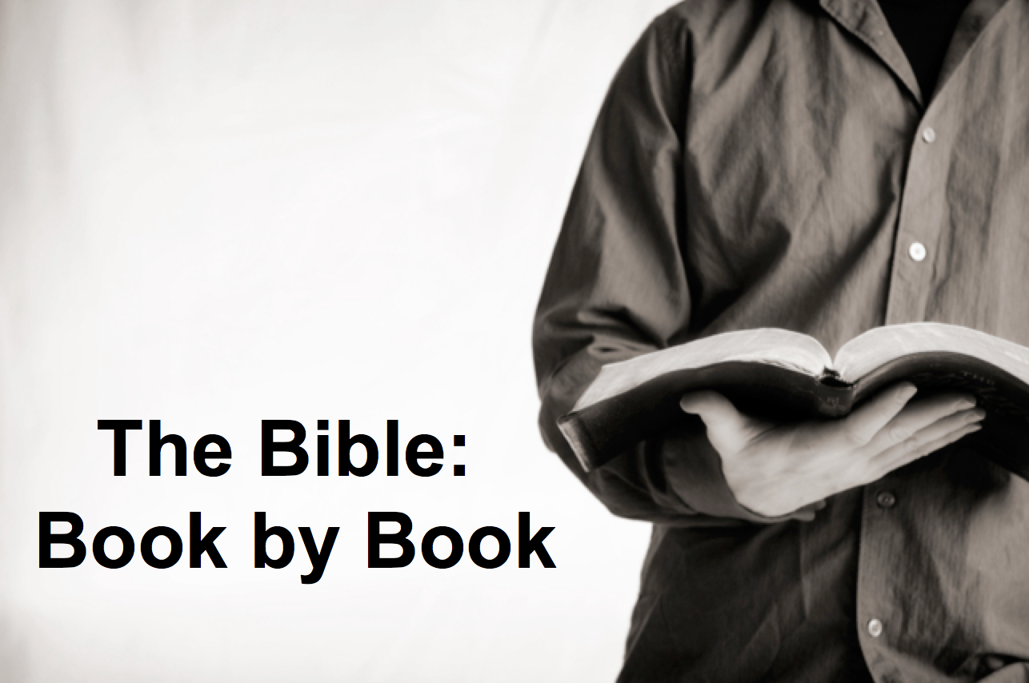

Rick Griffith
12 August 2018
Message 22 of 66

Be Loving
Song of Songs

Introduction

Marriage is under attack.

How can _______________ love become all that God designed?

I. _____________ for sex until marriage (1:1–5:1).

Solomon and the Shulammite express deep sexual desire for one another during their courtship accompanied by sexual restraint (1:1–3:5).

Solomon considered this song the best of the 1005 songs that he composed (1:1).

Solomon and the Shulammite express longing, insecurity, and praise as a prelude to the content of the entire poem (1:2-11).

The courtship intensifies but they remain patient until their wedding (1:12–3:5).

The couple has a royal wedding and the intimacy of their wedding night (3:6–5:1).

Solomon arrives for their wedding with the great pomp of a royal wedding (3:6-11).

The groom praises his bride on their wedding night and they consummate their marriage (4:1–5:1). (Note: “bride” appears six times and only in this section.)

II. _______________ for a good marriage (5:2–8:14).

The new marriage matures through struggles, praise, romance, and a request for greater intimacy to show that marital love takes work (5:2–8:4).

The wife (not “bride” as in 4:1–5:1) dreams that she shuns her husband's advances and becomes reconciled again (5:2–6:13).

Solomon praises the Shulammite’s beauty and she responds with a request for a romantic stroll and greater intimacy (7:1–8:4).

The Shulammite praises love's strength and their love story is in flashback form (8:5-14).

Conclusion

Be loving by _____________ and ______________ (Main Idea).

What should I do?

“Restore” (Chris August) at https://www.youtube.com/watch?v=eb9_7b6-T6g

Download this sermon PPT and notes for free at BibleStudyDownloads.org/resource/old-testament-preaching/
Listen to this message online at cicfamily.com/sermon-listing/

Solomon's Song of Songs

Dialogue of Marital Love

Courtship to Wedding |  |  |  |  | Growth in Marriage
1:1–5:1 |  |  |  |  | 5:2–8:14
Beginning of Love |  |  |  |  | Broadening of Love
Selfish Love  “My lover is mine and I am his” (2:16a) |  |  |  |  | Selfless Love  “I am my lover’s and he is mine” (6:3a)
Single |  | Married
Puppy Love |  | Love Untested |  | Love Tried and True |  |  |  | Love Recalled
Courtship  1:1–3:5 |  | Wedding  3:6–5:1 |  | Growth  5:2–8:4 |  |  |  | Flashback  8:5-14
Longing  1:1-11 | Intensification  1:12–3:5 | Procession  3:6-11 | Consummation  4:1–5:1 | Struggles  5:2–6:13 |  |  | Praise & Response  7:1–8:4 | Love’s Strength  8:5-7 | Love’s Virginity  8:8-14
Both at the vineyard |  |  | Honeymoon  begins | Honeymoon ends |  |  |  |  | Both at the vineyard
 |  |  |  | Break  up  5:2-16 |  | Make  up  6:1-13
ca. 1 Year

Key Word: Love

Key Verse: “I belong to my lover, and his desire is for me” (Song of Songs 7:10)

Summary Statement:
The love story of Solomon and his Shulammite wife from courtship to strong marital love shows the need for premarital sexual restraint and the effort required for growth in marital love.

Applications:

Exercise premarital sexual restraint so that marriage can be enjoyed to its fullest (i.e., allow love to blossom in its own time–2:7b; 3:5b; 8:4b).

Expect a good marriage to take work, and then work at it.

Compliment both the physical and non-physical virtues of your spouse.

